District Dell Chromebooks:
An Introduction for Parents
Adding personal/home Wi-Fi Networks

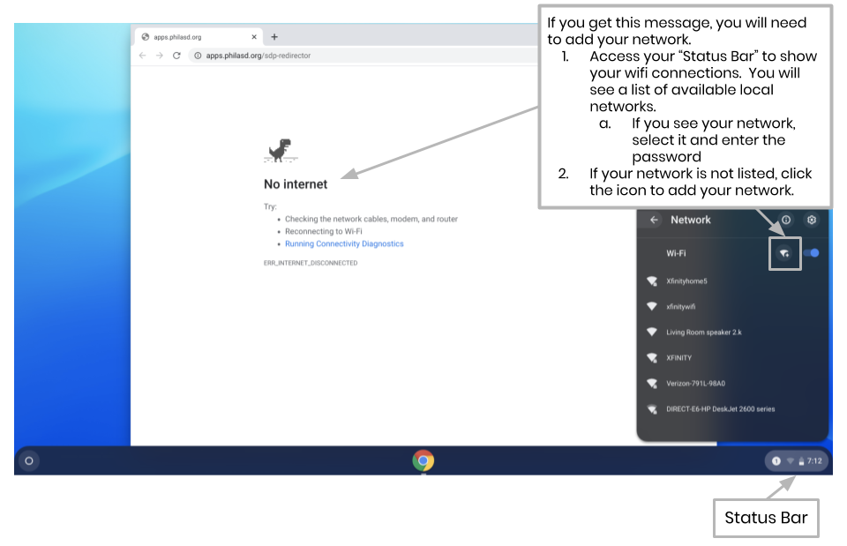
To add your Wi-Fi network, you will see this message when you activate your Chrome Browser. Follow the steps below to add your home network. Please note that you will need the SSID (or name) of the network you want to join, and the password to that network to gain access.

Navigating to Google Classroom, Lexia Achieve, and Imagine Math
For Parents & Students

- Type in the URL: “philasd.org”
- Click upper right corner: Login
- Put in your username which is your Student ID
Put in your password which is a short word with numbers
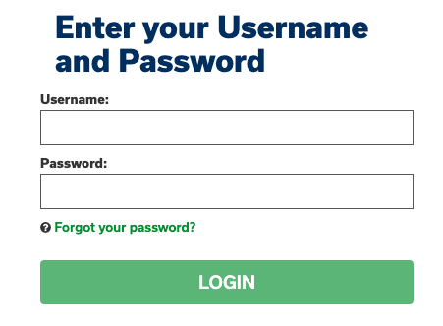
- Once logged in, you will be sent to SIS, a green Student Information Page
- On the bottom right side you will see “MESSAGE CENTER”
- Click “Message Center”
- It will look like this:
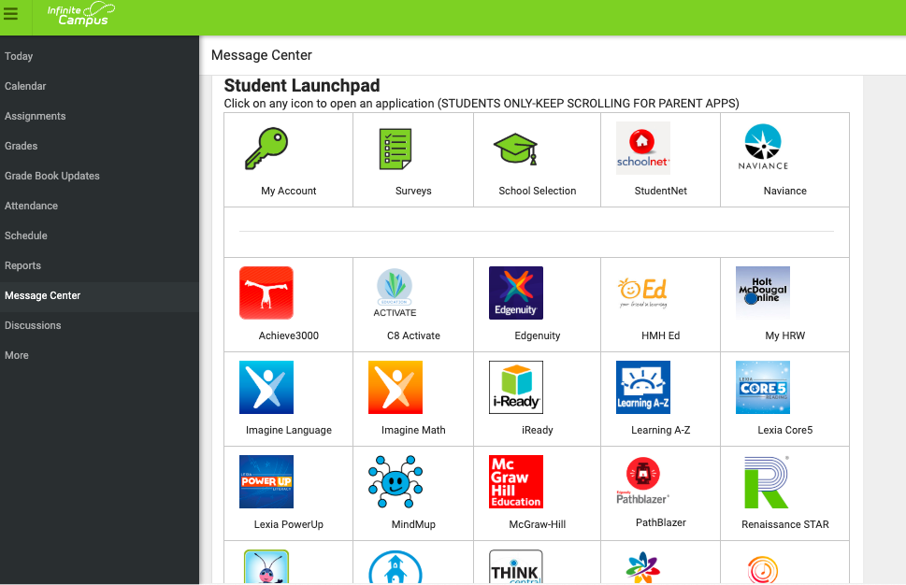
- Achieve 3000, Imagine Math and Lexia (CORE 5) are located on Third Row.
- Google Classroom is located below (Please Scroll down) with a Green Square
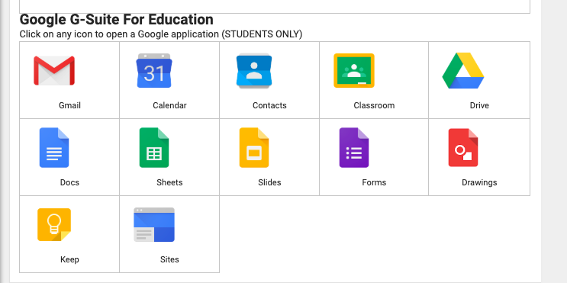

1. Now Click onto class of choice. Your assignment will be there.
Check back often for new Assignments!! Try them and do the best job you can.

How to Access Chrome & Navigate the Chromebook Desktop
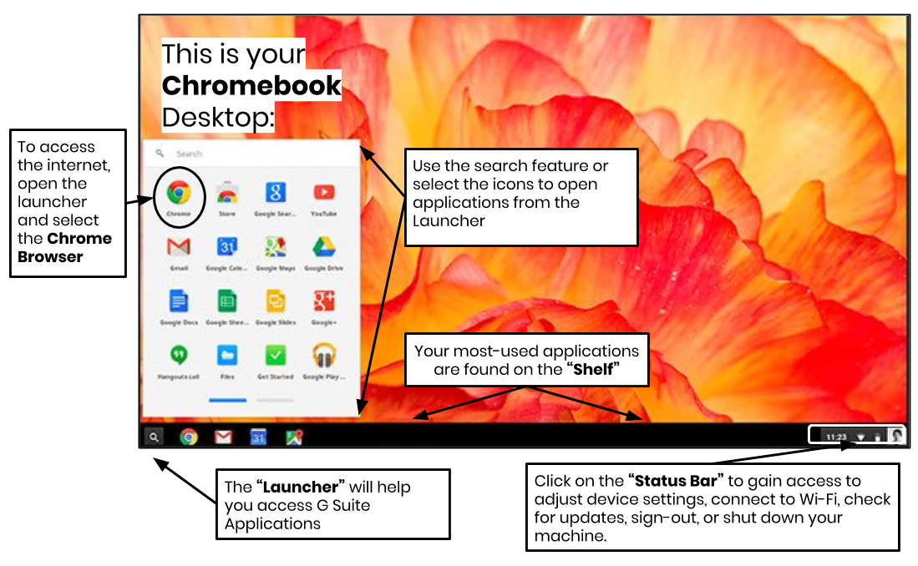

When looking at the Chromebook Desktop there are three main areas that users need to access: (1) the “Launcher” provides access to the Chrome Browser and other G Suite Applications, (2) the “Shelf” will show your frequently used applications, and (3) the “Status Bar” which expands into a menu that allows you to adjust settings for your device, monitor your Wi-Fi, sign-out and turn the Chromebook off.

Internet Access
Comcast
- Through April 30th, Comcast is offering two free months of Comcast Internet Essentials to new customers with limited means. See their website for eligibility requirements and more details.
- The simplest, fastest, and easiest way to apply for the program is from a mobile device at www.InternetEssentials.com. Call 1-855-8-INTERNET (1-855-846-8376) if you are having trouble signing up or don’t have access to an Internet-connected device. Note that Comcast call centers are experiencing heavy volume at this time. Please mention that you are a parent or guardian of a student in the School District.
- Xfinity WiFi Hotspots across the country will be available for free to anyone who needs them, including non-Xfinity Internet subscribers, through May 2020. For a map of Xfinity WiFi Hotspots, visit www.xfinity.com/wifi. Once connected to a Hotspot, consumers should select the “xfinitywifi” network name from the list of available networks, and then launch a browser.
Teacher Office Hours

During this time, teachers are available to connect with you via google classrooms & email to answer any questions you have!

Subject | Time
Expressive Arts  (Spanish, Gym, Art, Health) | 7:40AM - 9:00AM
English | 9:00AM - 10:30AM
Math | 10:30 - 12:00
Science | 12:00 - 1:30
Social Studies & AVID | 1:30 - 2:44

